Week beginning: 17th March 2025
This week in Chestnut
We are here to help. If you have any questions or concerns, please talk to your child’s keyworker or any of the staff.
Book of the week:  The Gruffalo  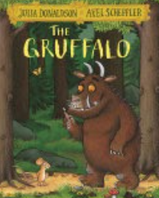 | Rhyme of the week:  The Finger Family Song  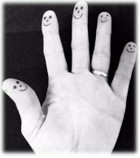 | Sign of the week:  Sit  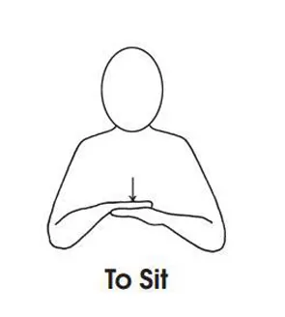 | Happy Thought of the week:  

Walk to the Woods:  - Before the walk we will be identifying and familiarising ourselves with the route we will take and three places that we will see on the walk to the woods. We will also be talking about the seasonal changes that we will observe on the walk to the Woods.  - When we go to the woods we will listen to an interactive telling of The Gruffalo and go on a hunt for the Gruffalo and the other characters from the story.  - After the walk we will look at photographs to reflect on our journey, talk about the experiences we had in the woods and the seasonal changes that we observed. | 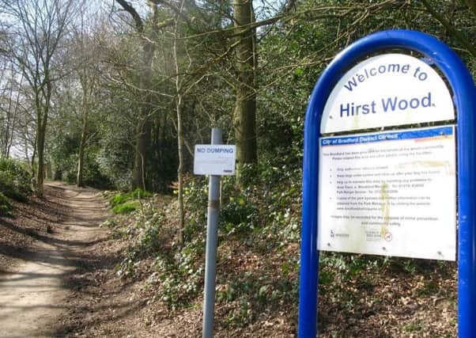
Learning opportunities:  We will be:  - Exploring the flow of water down pipes and guttering.  - Mark making on large sheets of paper using mark makers and in colored sand using our fingers.  - Some of us will be continuing to explore our interest in learning to write our name and write some numerals. | Help At Home:  We will be using Google Earth to find Saltaire and talk about the familiar local places that we can find. Explore Google Earth at home. Can you find your house? Can you find the houses of family and friends? Can you find any other places you have visited e.g. places in the UK and other countries. Take a virtual tour of the world and zoom in on some places that your child has shown an interest in e.g. going on safari in Africa.

Dates for your diary:
- WC 17th March Walk to the Woods.
- WC 17th March and WC 24th March Communication Calls. Sign up sheet outside classroom.
- Thursday 3rd April School closes for Easter Holidays. Please note Friday 4th April is a training day for staff.

