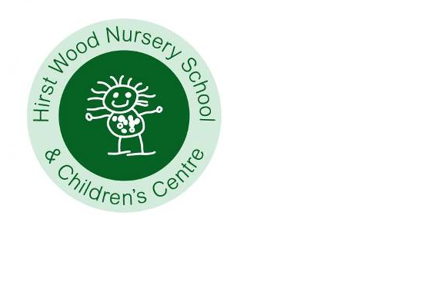
April 2025
Teaching and Learning
Welcome back, we hope that everyone enjoyed a relaxing Easter break. We are delighted to welcome new children this half term and are sure that you will make everyone feel welcomed. The weekly planning is available on the website www.hirstwoodnscc.co.uk and on the noticeboard outside. This will explain to you what activities we are doing and how this supports your child's learning. We would also love to see what you have been enjoying at home so please upload photographs and information via EYLog that we can share with the children. Don’t forget that children can change their library books every day – just bring your book back and swap it for another. Please return all books as our stock is running low. Research shows that involvement with reading activities at home has significant positive influences not only on reading achievement, language comprehension and expressive language skills, but also on children’s interest in reading, attitudes towards reading and attentiveness BUT above all, it is enjoyable! We have the adult’s lending library too … take a book to enjoy yourself.

By now you will have received your child’s Primary School allocation for September. We are starting to work with the Schools who will be welcoming your children in September. We encourage them to come and visits your child and talk to the teaching teams so that they can share all the amazing information about your child. The receiving schools will also be provided with a copy of your child’s leavers report and their final assessment data. All these documents will, of course, be shared with you towards the end of next term. For those children who are leaving us, please see the link below about what we feel are important in terms of school readiness. This is formed on a whole child approach and covers predominantly the personal, social and emotional skills that will support children as they move to a new setting. Some children suffer from increased anxiety when there is lots of talk about transitions, it may be worth considering how soon you start to talk to your child about moving school. PowerPoint Presentation (pacey.org.uk)

Our curriculum approaches
The implementation of our curriculum is based on a clear pedagogy which recognises the following key principles:
- Every child is unique, one who is constantly learning and can be resilient, capable, confident and self-assured.
- Children learn to be strong and independent through positive relationships.
- Children learn and develop in enabling environments with teaching in partnership with interested adults who respond to their individual interests.
- Children learn and develop at different rates and we celebrate all achievements equally.

We are proud to be able to offer an additional wide range of extra-curricular experiences to your children such as Yoga, Gardening Club, Music & Movement, All Aboard, Dough Disco, Forest School, Music & Movement and Story Tellers. These groups are an added enrichment to our curriculum offer and each child will have access to an additional club that we feel best suits their interests and learning styles.

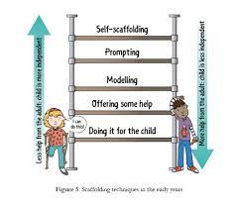
We need to know your children, spend time with them, working with and alongside, observing what they do, how, what and who with. We use three main techniques to ensure that our teaching and learning ensures children are engaged and adding to their skills, knowledge and understanding - scaffolding, feedback and metacognition. Scaffolding means that we give a child just enough help to do something which they couldn’t do independently. We gradually reduce the help until the child is independent. It’s a powerful technique for all children. Feedback means that we give children precise information about how well they are achieving something. That means that we need to talk with children first, or during their activity, about what their intention is. Feedback is sensitive, and it avoids general praise. It focuses on process and effort, as well as the final result. It helps children to improve their learning. We can usefully encourage children to seek feedback from each other. Metacognition is about children’s ability to plan ahead, monitor how well they are doing, make adaptations as they go, and review the final result of what they have been doing.
News and information – what’s coming up?
We have new children and their families joining us and we know that you will ensure that they feel welcomed. Claire Fagan will be moving to Chestnut on Thursday and Friday, and Alisha will be working more hours in Maple on those days.

We have a new lunchtime assistant, Hinna who will support Maple until the end of term.

Please note that from 22nd April School meals increase to £2.25 per day, which for two courses remains very good value.

New parents’ clinic Wednesday 23rd April from 9.15 to 10.30.
Come and join Ruth in the gallery to chat about all things children; the first session will focus on positive behaviour management, but after that, the topic of discussion will be led by you. Please email office@hirstwoodnscc.co.uk if you’d like to attend.

Wednesday 23rd April
Little Feet Project will be here to talk with children at group time before and after lunch about the importance of healthy walking habits.

Wednesday 7th May
Tempest Photography here all day. If you would like your child to have a photograph with their sibling(s), please let us know in advance and we will plan for this to happen before School from 8.30.


Week commencing 12th May is our “We are healthy” week and will be exploring how our body works and how we can look after it with different events happening every day.


We have balance bikes in the car park Tuesday 13th and Thursday 15th - all children will have the opportunity to participate (we will send home a copy of our risk assessment so that you can agree to your child taking part). These two days are also our special healthy shared platters for lunch.

Life Caravan is visiting Wednesday 14th May where children can learn about all the different senses we have, the bones and organs in our body and how to look after ourselves. They also get to meet Harold, the giraffe, (the mascot of Life Education Centre).

Wednesday 21st May fund-raising event
You will have noted by now that we never ask for any donations (other than towards snack), but we’d love to refresh some of our learning environments, particularly the outdoor area and wondered if you could support us. We thought a great way to do this would be to have a sponsored sing-along – please support us if you can, any donations would be appreciated. More details to follow, thank you in advance.


Health & Safety
During the summer months it may be necessary that children need
sun protection to be applied (hopefully!). We will provide sun cream for each classroom unless your child has specific skin sensitivities that would necessitate the use of their own specific cream. If this is the case, please bring in the sun protection clearly labelled
with your child’s name. If you could apply sun-cream to your child before they come to School and we will reapply it later in the day.


As children are accessing technology and the internet at a younger age than ever before, it’s important to be aware of how to keep safe online. Here’s a link to a useful website for you to explore with your children. https://www.ceopeducation.co.uk/parents/jessie-and-friends/

Dates to remember:
We are closed Monday 5th May for a Bank Holiday, reopen Tuesday 6th May.
We have a training day on Friday 23rd May so close to children on Thursday 22nd May
and re-open Monday 2nd June.

