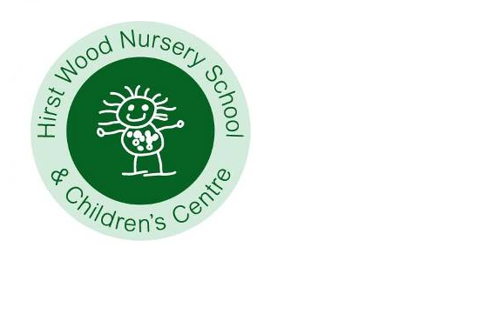

Charging and Remissions Policy

Review date: September 2024
Next review: September 2025

Introduction
The purpose of the policy is to ensure that there is clarity over those items which the School will provide free of charge and for those items where there may be a charge. This policy has due regard to all relevant legislation and statutory guidance including, but not limited to, the following:
- Education Act 1996
- Children Act 1989
- The Charges for Music Tuition (England) Regulations 2007
- The Education (Prescribed Public Examinations) (England) Regulations 2010
- Freedom of Information Act 2000
- DfE (2018) ‘Charging for school activities’
- DfE (2020) ‘Governance handbook’

This policy operates in conjunction with the following school policies:
- Complaints Procedures Policy
- Debt Recovery Policy
- Freedom of Information Policy
- Freedom of Information Publication Scheme

Definition
The school is open from 7.45am – 5.45pm Monday - Friday for 38 weeks per year

Responsibilities
The Headteacher will ensure that staff are familiar with and correctly apply this policy. The Governors will review the policy as part of their review cycle.

Items provided for free
All activities that are a considered part of the Statutory framework for the early years foundation stage Setting the standards for learning, development and care for children from birth to five (2021) will be provided free of charge. This includes all materials, resources and curriculum enhancements.

Hours of Provision
15-hour options (free of charge)
Monday to Wednesday Monday & Tuesday 9.00 to 3.15, Wednesday 9.00 to 11.30
Wednesday to Friday Wednesday 12.45 to 3.15, Thursday & Friday 9.00 to 3.15

30-hour options (free of charge, subject to eligibility criteria)
3 x 10 hours Monday, Tuesday, Wednesday 07.45 to 5.45
3 x 10 hours Wednesday, Thursday, Friday 07.45 to 5.45
5 x 6 hours Monday to Friday 9.00 to 3.15

Additional charges / contributions
Snack £ 7.00 per term children attending 15 hours
£14.00 per term children attending 30 hours

Lunchtime meal £ 2.10 per day *
*This rate is set by City of Bradford Metropolitan District Council which is reviewed annually in January.

We collect the payments collect on their behalf of the Local Authority. We do not charge above their rate to accrue any increased profit for Hirst Wood Nursery School.

Wraparound provision (Additional sessions subject to capacity)
Before school 7.45 to 9.00 £ 7.00 per session
After school session 3.15 to 5.45 £14.00 per session
Half day 9.00 to 11.30 £19.50 per session
Half day 12.45 to 3.15 £19.50 per session
Full day 9.00 to 3.15 £49.50 per session
Lunchtime session 11.30 to 12.45 £ 9.00 per session

Voluntary contributions
Voluntary contributions may be sought for activities during the school day which entail additional costs, for example educational outings and visits. In these circumstances no child will be prevented from participating because his/her parents cannot or will not contribute, however if sufficient funds are not available it may be necessary to curtail or cancel activities. (See Educational Outings Policy).

Optional activities outside of the school day
We may charge for optional, extra activities provided outside of the school day for example holiday events, visits etc.

Calculating charges
When charges are made for any activity, whether during or outside of the school day, they will be based on the actual costs incurred, divided by the total number of children/families participating. There will be no levy on those who can pay to support those who can’t or won’t. Support for cases of hardship may be considered though the use of voluntary contributions or fundraising.

Photocopying
A charge may be made for photocopying of any documents provided to parents and outside agencies at cost (including admin time), which is not related to school activities. We will not charge for the photocopying of any School policies.

Lettings - See Lettings Policy

