Dear Parents and carers

On behalf of everyone at Hirst Wood Nursery School, we welcome you to our community. We’re here to give your child the best possible early years education and care. We work hard to develop a respectful partnership with every parent. We work hard to maintain our high standards and to keep improving. We want your child to have a happy and successful time with us, so they’re ready to continue their learning and every experience that is available to them.

**Working with parents**

* We work closely with parents and carers to support every child as an individual. We help every child to grow up feeling confident about their identity, in a spirit of friendship.
* We value the diversity in our local community.
* We are here to help support you and your family in every way

**Promoting positive behaviour**

We want every child to keep learning how to behave positively whilst they are with us. This includes making friends, sharing and playing together, and coping with disagreements. Some non-compliance is typical as young children develop their independence and autonomy. Tantrums, hitting and biting are also common: physical aggression in humans reaches its peak at the ages of two and three-years old. Young children want to express themselves, but they find it difficult. It is important for parents and practitioners to respond calmly and be clear and consistent. Children who are treated harshly are more likely to become aggressive. We are working hard to support children’s emotional literacy so that they can recognise and label their feelings so that we can support them appropriately.

**Co and self-regulation techniques**

At its simplest, co-regulation is when an adult helps a child self soothe in times of stress. It's a building block for self-regulation, and a big step in learning how to handle our own feelings, which is why it is so important to start co-regulation in early childhood. In terms of child development, co-regulating is about sharing space with a child as they move from a dysregulated state to a regulated state. A regulated state, also known as “emotional regulation,” is having the right energy or stimulus level for a given situation.

Children often became dysregulated in ways that are difficult for adults to understand, but before we can understand the reason for dysregulation, we have to help children regulate. At the point of dysregulation, they can’t tell us why they are upset as they have difficulty using the rational part of the brain.

We provide children with regulation space for them to feel calm (this can be anywhere in the classroom that provides a small space away from others for children and adults to work together), and supporting children to recognise the energy they need for the situation and helping them to regulate, which could include knowing when an alerting activity might be helpful. It could be having resources that you can help them to take into another space that will support regulation, this is not a sanction or a place for ‘time out’.

**How does co-regulation work with children?**

We consider co-regulation as sharing space and a relationship with children, working through strong feelings and helping them self-regulate their emotional state. Some approaches we use are: approaching children calmly. Labelling the child’s emotions, both the feeling and how it shows up in their body. Assisting the child with finding a calming strategy, such as taking deep, controlled breaths together. Hugging a soft toy, or perhaps a trusted adult. Swinging or rocking. Moving away from context that is causing distress.

Self-regulation is what the child does, and the co-regulating focuses on the adult’s role. But self-regulation skills don’t happen overnight — children need supportive adults. That’s where co-regulation comes in.

**Children need to know what is expected and guidelines are important**

It is important to highlight that moving away from behaviourist approaches does not mean the adults do not set limits. It means that the way these are shared and set is built on a foundation of positive relationships. This means at the start of each intake the focus is on building relationships, rather than introducing rewards and sanctions. The focus of supporting children’s behaviour is on teaching and not compliance. We want children to have intrinsic motivation to follow the guidelines, rather than offering rewards such as stickers.

**Emotion coaching - and use of empathy/mind-minded comments**

Emotion coaching involves responding with empathy and joining children in problem-solving while setting clear limits on behaviour, what is and is not acceptable. This also involves adults recognising and accepting children’s emotions, rather than dismissing those we view as ‘negative’. We aim to give children the emotional literacy to label how they are feeling, and what we can do together to help, support and guide children. it’s a lot easier for children to separate themselves from their overwhelming feelings, once you give those feelings a name. Also, describing how these big feelings show up in their body allows them to notice how this feeling is affecting them, so they can start self-soothing.

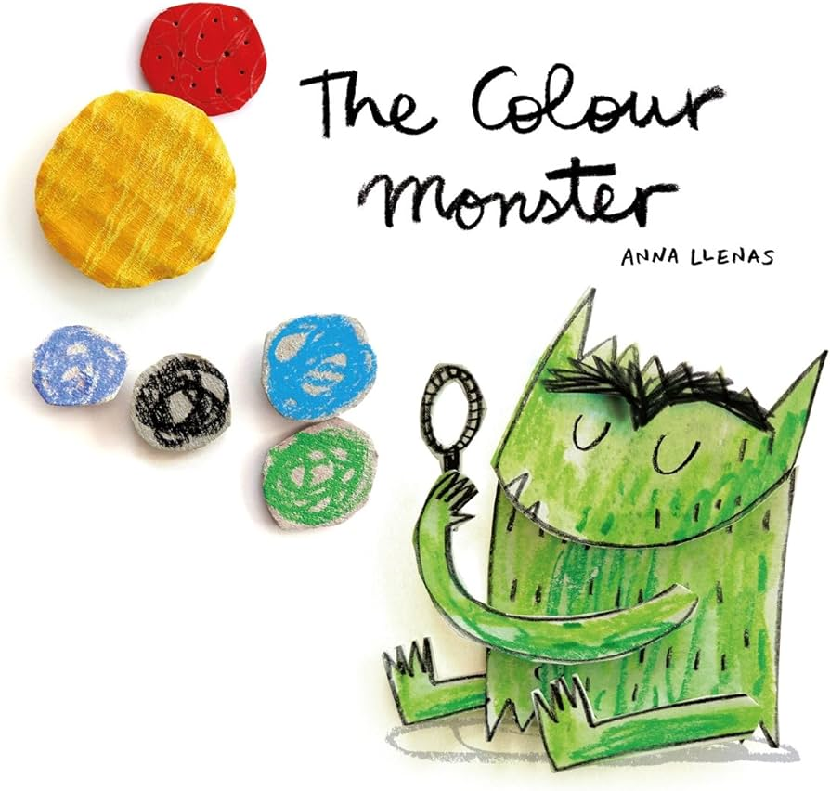

In each classroom we have displays of ‘Zones of Regulation’ that utilises images from The Colour Monster with the accompanying emotion such as angry, sad, happy etc., The gaining of emotional literacy is on a continuum, and we work with children to understand the fundamental emotions first, working towards other more complex feelings such as annoyed, frustrated, disappointed. Children are encouraged to ‘check in’ during the sessions by putting their name card under the emotion that they are feeling, which allows adults the opportunity to review this with them during the day.

Staff are experts in supporting children’s emotional wellbeing and managing their behaviour. If a colleague raises concerns about your child’s behaviour, it’s so that we can work together to help them learn to get along with other children. We want to have zero-violence (slapping, smacking or biting) in School. We need you to help us.

If your child is hurt by another, we’ll work with both children to prevent that from happening again. However, things happen quickly when children are young. We promise that we will do our best, but we cannot guarantee that it won’t happen again.

We help all children learn to be strong and able to say ‘no’ clearly if they don’t like something. The Department for Education defines bullying as ‘behaviour by an individual or group, repeated over time, that intentionally hurts another individual or group either physically or emotionally.’ It is rare for a young child to be intentional like this, however we do not tolerate bullying and will work to tackle the very rare instances whenever they occur.

To provide a consistent response to children’s emotional contexts, we are implementing a restorative justice approach. This means that we talk to children about what has happened, how they feel and what possible actions could make it better.

**Restorative justice**

Restorative Practice provides us with a value base, language, behaviours and tools to strengthen relationships with children and families and each other. Our restorative approach focuses on empowering children and families to find solutions to their problems and recognises them as experts of their own lives. Restorative Practice is about putting strong, meaningful and trusting relationships at the heart of how we work with children and families.

This approach will develop a happier school where the focus is on learning not conflict. Every member of our school community should feel safe and respected and will know that when things go wrong we will do everything we can to help put it right.

A school making a conscious decision to become restorative also opens a door to a new mindset and culture shift. It focuses on positive relationships and collaborative teaching and learning, with classrooms developing as communities. It means that we all to looking at positive alternatives to reactive behaviour solutions, because we are confident that the matter is being dealt with in a clear and explicit way, understood and endorsed by all.

Restorative practice is a proactive way of working WITH people, not doing things TO them, not doing things FOR them and NOT being neglectful and doing nothing at all. We are looking to increase the opportunities for dialogue at every level, especially with you as your child’s most important people.

Restorative approaches encourage people to think about how their behaviour has affected others. Our whole community is restorative and adults model the use of these approaches for our pupils which aims to develop respect, responsibility and truth telling. If your child has been upset we will try our very best to make sure they feel that it has been put right for them. If a child has done something which has caused harm to another they will have the opportunity to repair this harm in a meaningful way.

This is not a ‘soft option’, it is challenging and encourages children to take accountability for their actions. Restorative approaches are part of a positive behaviour strategy, and not only used when things ‘go wrong’.

**The identified benefits are**

* Children practising sharing their emotions and feelings, developing their emotional literacy
* 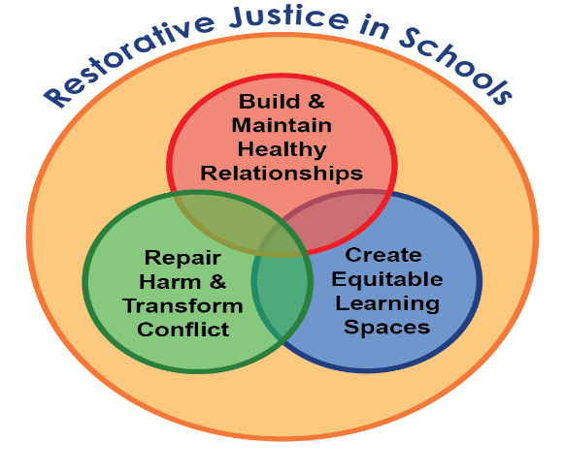Children identifying what is unfair
* Children actively discussing their needs
* Children taking responsibility for their actions and their impact on others
* Greatly improved honesty and prompt truth telling
* Improved understanding that their behaviour may upset others
* Mutually respectful relationships
* More effective teaching and learning opportunities
* A meaningful and developmentally appropriate way of addressing negative behaviours
* Raising morale by developing a culture of inclusion and belonging

Traditional methods have previously used to shame and guilt young children who've made the wrong behaviour choice, yet, with restorative practice, the process includes getting to the source of the behaviour (which we know is communication) and how children can learn and grow from the experience.

All children communicate and express themselves differently and may demonstrate this through emotional outbursts, anger, defiance, physical harm, or disruption. There are various ways to respond to these actions, which include redirecting their behaviour, using guidance to create a more positive environment, using conventional disciplinary methods such as taking away privileges and giving punishment, but restorative practices are proven to

* 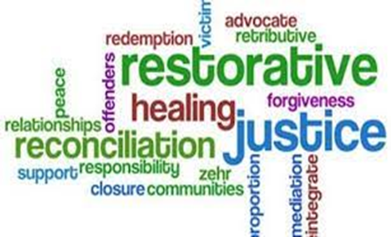Build healthy relationships
* Develop conflict resolution skills (these will be lifelong)
* Create a strong sense of belonging, and being valued
* Repair the harm that's been done

**What does working restoratively look like in practice?**

There are 5 principles to restorative practice.

Relationships – developing connections

Respect – valuing others

Responsibility – being accountable for our actions

Reintegration – being a consistent member of the community

Repair – repairing harm

Our ambition is for everyone who works with children and families to be able to follow a consistent restorative way of working which is guided by our core principles and values and informed by evidence-based approaches.

Consistency does not mean rigidity; our approach is designed to be adaptable and flexible to respond to individual need but is centred on a restorative value base. To help support children we are using a set of consistent questions so that we all respond in the same predictable way. Perhaps you could support us with this approach at home by using the 4 simple questions below. Please let us know if you’d like any further advice or support.

**Repairing when things go wrong**

**What happened?**

**How did you feel?**

**How can we make it right?**

**What can we do next time?**